FULL STACK SOFTWARE DEVELOPER

ADÉNA MURÁNCSIK

https://cv.pegazus.space

+33 6 46 74 60 21 – adena.murancsik@gmail.com

**SKILLS**

|  |  |
| --- | --- |
| **LANGUAGES** | C# • JavaScript • TypeScript • Python • HTML • CSS • SQL • Bash scripting • PowerShell scripting |
| **FRONTEND TECHNOLOGIES** | WPF • ASP.NET • jQuery |
| *JavaScript Frameworks* | AngularJS 1.5 • Angular 6-11 • React / Redux |
| *CSS* | Chrome 30-compatible CSS • SCSS • LESS • CSS-in-JS • Angular Material • React Material |
| **BACKEND TECHNOLOGIES** | WCF • LINQ • Entity Framework 4-6 • ASP.NET Web API • Flask • Restful Services • SOAP • RabbitMQ |
| **SQL** | SQL Server 2008-2012 • Oracle 11g • PostgreSQL • Microsoft T-SQL |
| **DEVOPS** | Jenkins • Bamboo • SonarQube • Docker • IIS |
| **OS ADMINISTRATION** | Windows Server 2016-2019 • Debian 10 • CentOS 6-7 |
| **UI/UX** | CorelDRAW • Adobe Illustrator • Adobe XD |

**WORK EXPERIENCE**

**Jul 2019 – *(present)***

**Full Stack Engineer**

*Silversea Cruises, Monaco*

**Oct 2020 – (present):**

Architectural design, UI/UX design proposition and active development of a new, React-based project to create an extensible web application for managing recurring onboard tasks to be performed by the crew.

Clients include set-top boxes for TVs (Biggest challenge was to optimize the layout to be comfortably readable from 10 feet away; and the navigation should be easy via remote control).

Role: **Development lead**

Team size: **2 people**

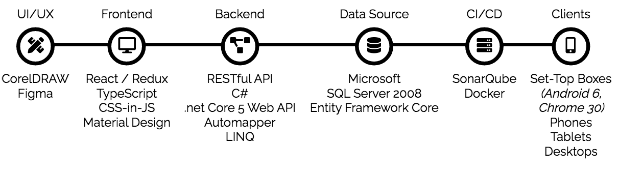

**Jul 2019 – Oct 2020**

Architectural design, multiple UI/UX design propositions, development, deployment, field support on entire modules for guest-facing interactive TV systems.

Modules I actively participated in:

* Home Automation System for cabins
* Public Announcement System (with Raspberry Pi, Python, NAudio)
* Multimedia content ingestion automations (Bash scripting under CentOS 6)
* Paperless evolutions: implementation of daily newspaper / daily chronicles on TV and mobile

Team size: **4-6 people**

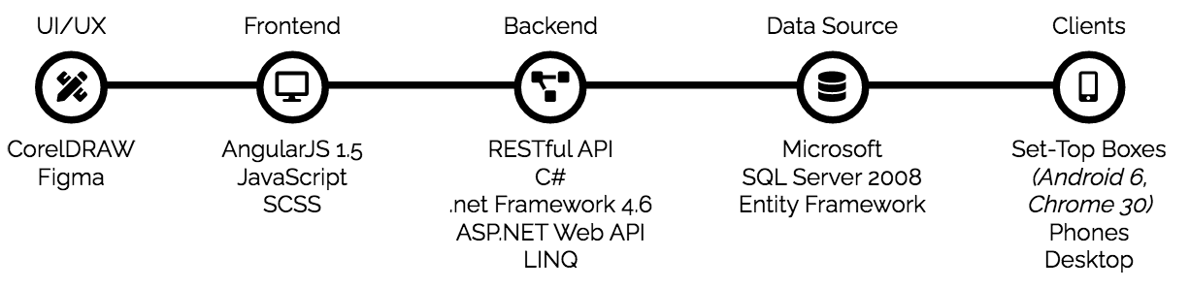

**Sept 2015 – Jul 2019**

**Full Stack Developer**

*International Gaming Technologies, Monaco*

**Sept 2018 – May 2019**

Created Angular-based web application from scratch for Casino Reception Management

My main role in the development team was the UI/UX/Animations/Form interactivity.

Team size: **6-10 people**

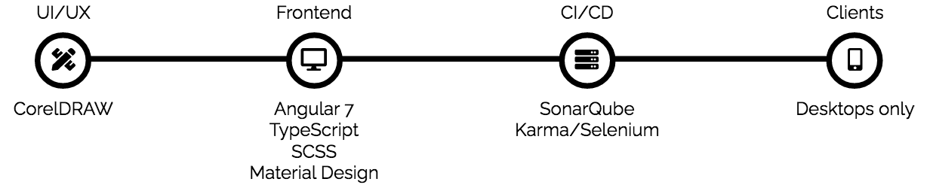

**Sept 2015 – Sept 2018**

Develop and maintain WPF thick client for casino management to check, overview and audit gaming floor status in real time.

The most challenging part was to integrate applications made in newer architecture in a heterogeneous software environment.

Involved in project management between June 2017 and June 2018 – 4 team members reported to me.

Team size: **4-6 people**

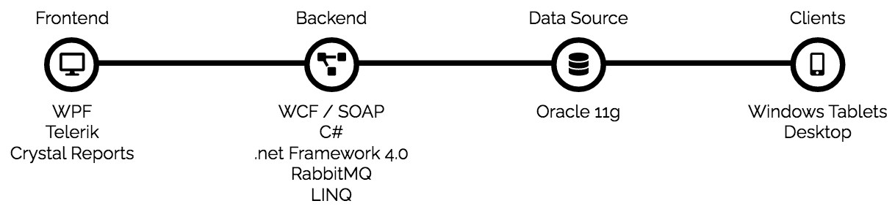

**Jan 2014 – Aug 2015**

**Application Interface Developer**

*Systemax SBS Hungary Kft., Budapest, Hungary / Paris, France*

Development and maintenance on an in-house application for retrieving product data tables from external vendors and integrate it into Systemax's management system.

Developed several parts of a module which was responsible for big data importing - performance was the key. The goal was to import and process millions of products, photos, additional data for the shortest period of time.

Team size: **4 people**

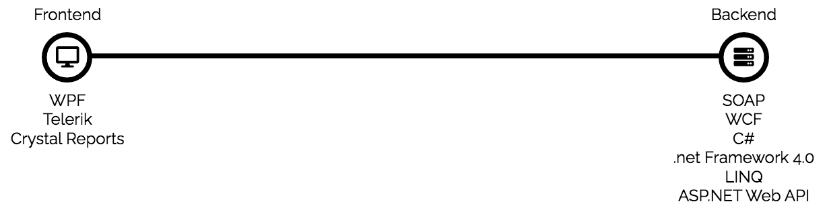

**Aug 2012 – Jan 2014**

**C# Developer**

*Laurel Holding / Progadat Kft., Budapest, Hungary*

Developed trading / storage managing software for the National Tobacco Shops and national supermarket chains.

Team size: **12 people**

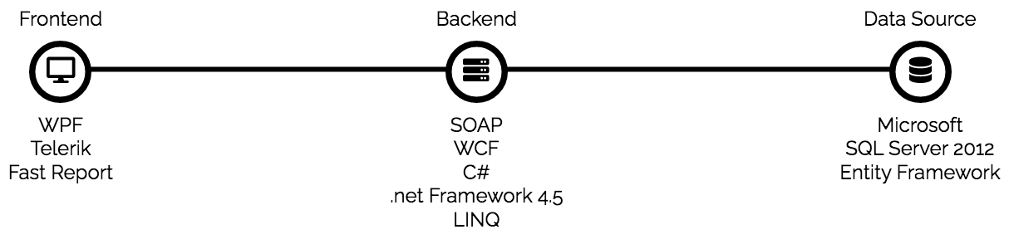

**Jan 2011 – Aug 2012**

**C# Developer**

*Mininform Kft., Szeged, Hungary*

Developed car parking subscription controller application for handheld devices.

Team size: **3 people**

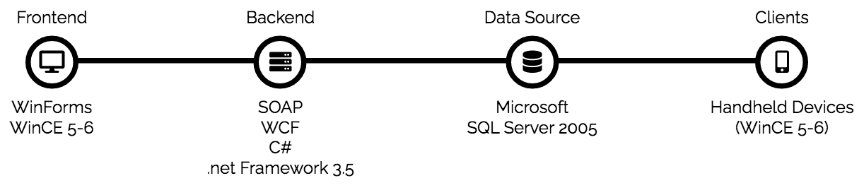

**EDUCATION**

|  |  |
| --- | --- |
| **2012**  *thesis* | Implementation of simulation environment of the operating systems' file system. I created a cloud-based storage implementation with their handlers and an exemplary client application, in C# |
| **2009 - 2012** | Computer Science Degree, BSc (Bac+3)  University of Szeged  Szeged, HUNGARY |